Introduction to Python

- Overview
Python is one of the most popular programming languages in the world today. Invented by Guido van Rossum in 1990, it is a modern general purpose programming language powering cloud, web development, data science, artificial intelligence, automation. Known for its simplicity and versatility, its main function is to reduce developer effort. Its design philosophy emphasizes readability and ease of use, making it an excellent choice for beginners and professionals alike.

2. Key Features of Python
- Readable and Simple Syntax
Python’s syntax is close to natural language, reducing the learning curve for new programmers.
- Interpreted Language
Python does not require compilation; it runs directly, which speeds up development and testing.
- Cross-Platform Compatibility
Python works seamlessly on Windows, macOS, Linux, and even mobile platforms.
- Extensive Standard Library
Python comes with a rich set of built-in modules for tasks like file handling, networking, and data processing.
- Provides Foundation
Python provides foundation for cloud, web development, data science, artificial intelligence, automation.
- Object-Oriented and Functional Support
Python supports multiple programming paradigms, including object-oriented, functional, and procedural styles.
- Large Community and Ecosystem
With millions of developers worldwide, Python has strong community support and abundant resources.
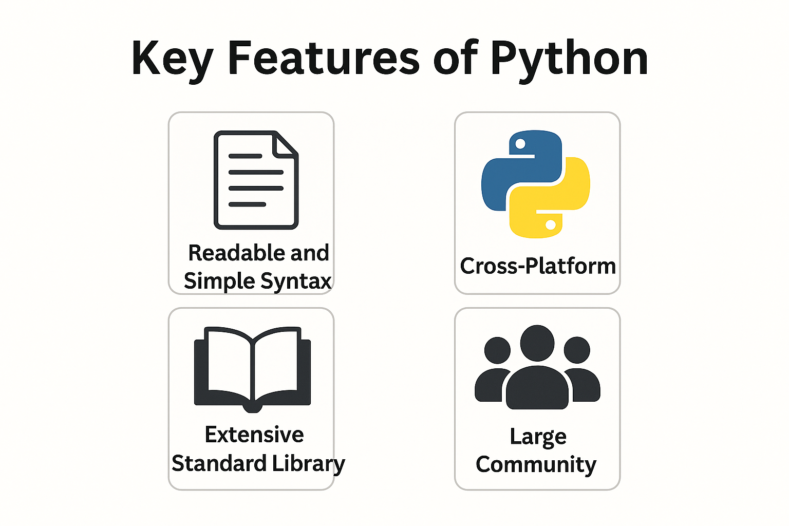

3. Advantages of Python
- Beginner-Friendly
Its simplicity makes Python ideal for those new to programming.
- Rapid Development
Python’s concise syntax and powerful libraries allow developers to build applications quickly.
- Versatility
Python is used in:
  - Web Development (Django, Flask)
  - Game Development
  - Cybersecurity Tools
  - ETL and Data Engineering
  - AI/ML pipelines
  - Cloud resource automation
  - API Driver Automation
  - Application scripting
- Integration Capabilities
Python integrates easily with other languages like C, C++, and Java, and supports APIs for various platforms.
- Strong Community Support
Extensive documentation, tutorials, and forums make troubleshooting easier.
- Short Development Time
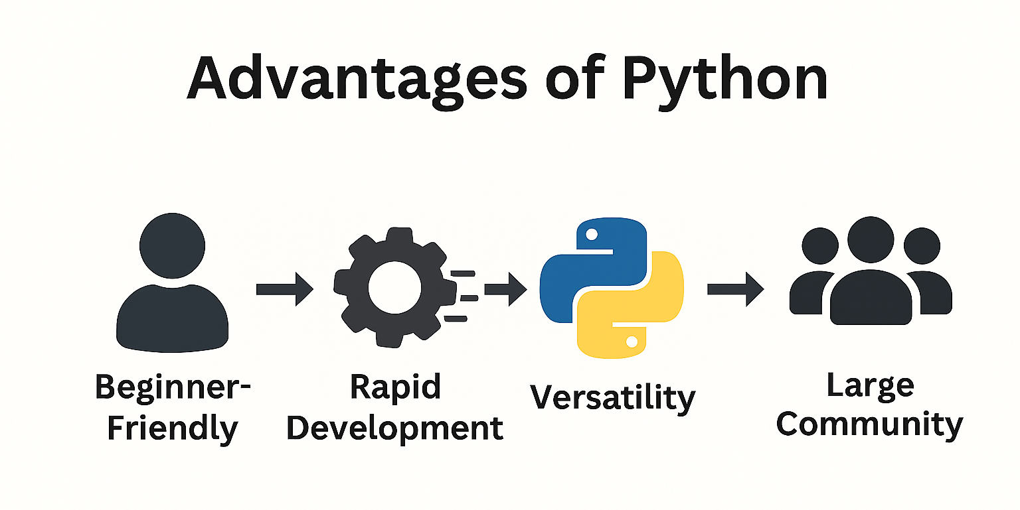
Python requires less development time.

4. Comparisons with Other Languages
Python vs Java
- Ease of Use: Python is simpler and more readable than Java.
- Less Boilerplate: Python has less boilerplate than Java.
Python vs C++
- Complexity: C++ is more complex and requires manual memory management; Python handles memory automatically.
- Performance: C++ is faster for system-level programming; Python trades speed for simplicity and flexibility.
Python vs JavaScript
- Domain: JavaScript is primarily for web front-end; Python is stronger for back-end scripting, data science, and automation.
- Learning Curve: Python is easier for beginners compared to JavaScript.
Python vs R
- Python is more general purpose and better for production than R.
Python vs Shell- scripting
- Python is more powerful and scalable for automation than Shell-scripting.

5. Why Python is Popular
- Adaptability: Works across multiple domains and industries.
- Community Support: Millions of developers contribute to libraries and frameworks.
- Future-Oriented: Python is a leading language in AI and machine learning, ensuring long-term relevance.
- Microservice: It is easier to create microservice in python
- Clean integration: It integrates cleanly with Azure, AWAS, GCP, Snowflake, Databricks, Docker, Kubernetes.
- Massive libraries: Python has massive standard libraries.
- CI/CD scripting: Python is excellent for CI/CD scripting.

6. Conclusion
Python has established itself as one of the most influential and widely adopted programming languages due to its simplicity, flexibility, and powerful ecosystem. Its readable syntax and extensive libraries make it ideal for rapid development across diverse domains—ranging from web applications and automation to data science and artificial intelligence. Supported by a vibrant global community and continuous innovation, Python remains a future-proof choice for both beginners and experienced developers. Whether you aim to build small scripts or enterprise-level solutions, Python provides the tools, scalability, and adaptability to turn ideas into reality.

